Department of Mechanical Engineering
Michigan State University
East Lansing, MI 48824-1226

ME451 Laboratory

Modeling and Experimental Validation of a
First Order Plant Model: DC Servo Motor

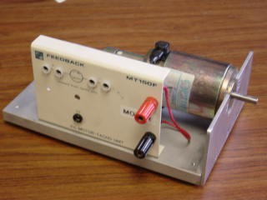

__________________
ME451 Laboratory Manual Pages, Last Revised: 1/14/2010
Send comments to: Dr. Clark Radcliffe, Professor

References:
C.L. Phillips and R.D. Harbor, Feedback Control Systems, Prentice Hall, 4th Ed.
Section 2.7, pp. 38-43: Electromechanical Systems
Section 4.1, pp. 116-120: Time Response of First Order Systems
Appendix B, pp. 635-650: Laplace Transform
(Particularly the “Final Value Theorem…)

1. Objective
Linear time-invariant dynamical systems are categorized under first-order systems, second-order systems, and higher-order systems. The transfer function of all first-order systems has a standard form. This enables us to investigate the response of first-order systems collectively, for any specific input. The response of a first-order system depends on its DC gain, , and time constant, . Both and are function of system parameters. The objective of this experiment is to model a first-order system and investigate the effect of system parameters on its response to a step input.
We choose to experiment with an armature controlled DC servomotor, which behaves as a first-order system when the armature voltage is the input and the angular speed is the output. We obtain the transfer function of the motor and identify specific parameters of the system that affect system response. Specifically, we identify system parameters that individually affect the DC gain and the time constant and vary these parameters to experimentally verify the change in system response.

2. Background

2.1. First-order systems
The standard form of transfer function of a first-order system is:
(1)
where and are the Laplace transforms of the output and input variables, respectively, is the DC gain, and is the time constant. For a unit step input , the response of the system is:
(2)
The inverse of the resulting Laplace transform can be easily found (see the Appendix in your text). Typically the inverse is available in standard tables. In this case,
(3)
It is clear from (3)) that as . The DC gain can therefore be interpreted as the final value of the output for a unit step input. The time constant is the time required for to reach 63.2% of its final value. Indeed, at , for a unit step input. For a unit step input, the change in input is one (1). In general, for a step input of magnitude , at , . The response of the first-order system to a unit step input is shown in Fig.1a for two cases. For a system gain, the system’s output change is less than the input change applied. For a system gain. the system’s output change is more than the input change applied. The results plotted are for a system operating for small positive input and output deviations from zero (the origin).

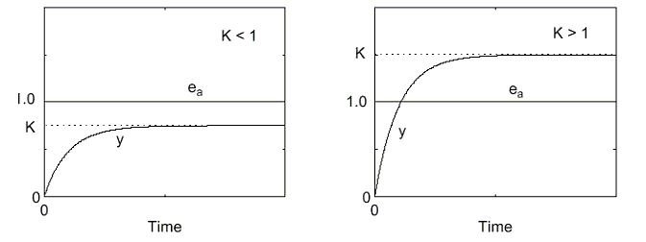
Figure 1a: First-Order System Step Response
Figure 1b: Periodic First-Order System Step Response
The step response of the DC motor will be evaluated with a square wave input composed of a series of positive and negative steps. As shown in Figure 1b, these steps produce repeated positive and negative changes in a 1st order system’s output. Assuming the positive system’s response reaches steady-state for each positive and negative input, the gain and time constant parameters can be separately evaluated for both positive and negative input changes. The specific values for the gain and time constant parameters for the above systems are computed below. Notice that the system gains are equal but that the positive and negative change time constants are not. For both parameters, an average is typically used as a representative value. The variation from the average indicates the repeatability of the measurement.
Table 1: Typical Gain and Time Constant Measurements and Computations
 | Input Change  ΔInput | Output Change  ΔOutput | Time to  63.2% change | System Gain  ΔOutput/ΔInput | Time Constant  τ
Rising | 0.9-0.0 = 0.9 | 0.65 | 0.8-0.0 = 0.8 | 0.65/0.9 = 0.7 | 0.8
Falling | 0.0-0.9=-0.9 | 0.65 | 6.2-5.0 = 1.2 | 0.65/0.9 = 0.7 | 1.2
Average | ----------- | -------------- | -------------- | 0.7 ± 0.0 | 1.0 ± 0.2

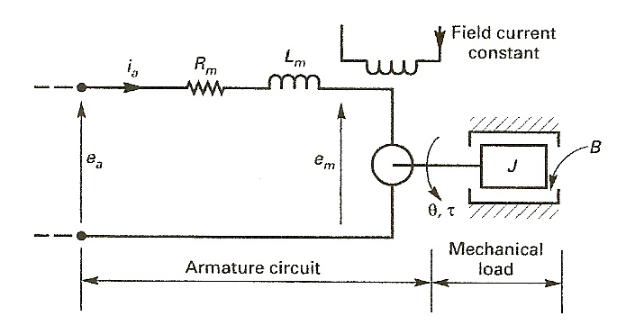
Figure 2: The DC Servomotor (Phillips and Harbor)

2.2. DC Servo Motor System
A schematic diagram of an armature controlled DC servomotor is shown in Fig.2. The system variables include:
: armature drive potential (volts).
: back emf potential (volts)
: armature current (Amps)
: torque produced by motor (N-m)
: angular position of motor shaft (radians)
: angular velocity of motor shaft (rad/sec)
The parameters of the system include:
: armature resistance (Ohms)
: armature inductance (Henry)
: moment of inertia of motor shaft (Kg-m²)
: coefficient of viscous friction (N-m-sec/rad)
The system parameters not shown in Fig.2 include:
: torque constant (N-m/Amp)
: motor back emf constant (volt-sec/rad)
The torque constant models (Phillips and Harbor, 4th Edition,, Section 2.7.2) the relationship between the electric current input and motor torque output.
(4)
The back EMF constant models the relationship between the motor speed input and the electrical back emf produced by the DC motor,
(5)
The transfer function of the servomotor, with armature drive potential e_{a} as input and motor speed as output, can be written as (Phillips and Harbor, Section 2.72)
(6)
Typically, the inductance of the motor armature is relatively small. Neglecting the armature inertia 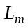, yields the low speed approximation for the DC servo motor transfer function (Phillips and Harbor, Section 2.72)
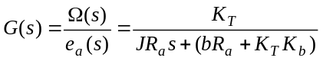 (7)
Rewriting (7) is the standard 1st order transfer function form (1) yields
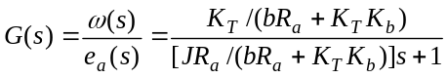 (8)
and comparing it with (1), we obtain the expression for the motor DC gain:
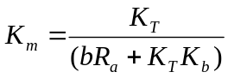 (9)
and the DC motor time constant:
(10)

Motor
Speed

Amplifier
Drive

Motor
Drive

Figure 3: Block Diagram of the Motor and Amplifier System.

An amplifier is often used to generate the power required to drive the armature voltage on the motor. A block diagram showing an amplifier connected to the motor transfer function is shown in Fig. 3. The amplifier modeled as a constant gain, is also shown.. Together, the motor and the amplifier can be modeled as a single first-order system with steady-state (DC) gain:
(11)
and the time constant:
(12)
Comparing (9) and (11), the DC gain of the motor and amplifier system is the product of the motor DC gain and the gain of the amplifier.
(13)
A comparison of (10) and (12) indicates that the time constant of the motor plus amplifier system is the same as the motor time constant alone. One of the primary objectives of this experiment is to study those effects that vary the system’s DC gain and the time constant. Although it is possible to vary the system’s DC gain by varying the amplifier gain , we will not vary in this experiment. We will vary the system’s time constant by changing the inertia of the motor shaft J by mounting an inertia disk on the motor shaft. The above analysis shows that we expect these two changes to have independent effects on the motor system response.

Pre-Lab Sample Questions
1) From the plot below, what is the DC gain of the system?
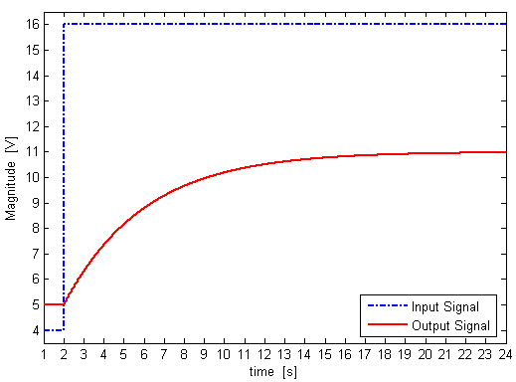
Answer: DC gain = 0.5
2) From the plot below, what is the time constant of the system?
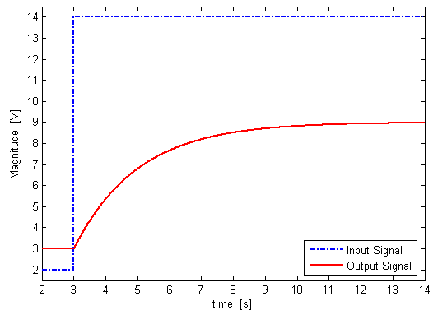
Answer: τ = 2 sec

3) The first-order system below is composed of an amplifier and a plant. Find the system transfer function in standard first-order form, K/(τs+1)
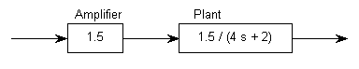
Answer: T =

4) Sketch the output of the system below for a unit input. Be as specific as possible.
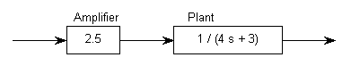
Answer:
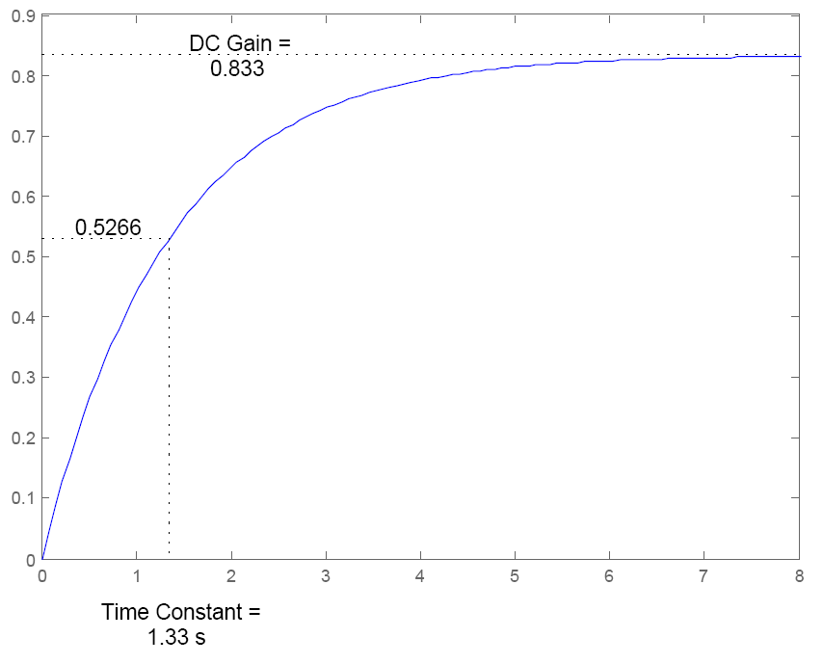

3. Description of Experimental Setup

3.1. Hardware and software

1. Power amplifier TOE7610
This unit provides amplifies the input signal at ‘input’ port and delivers the amplified signal at ‘+’ and ‘–’ output ports.

2. DC motor-tachometer unit MT150F
Tachometer converts the rpm measurement to Voltage that can be measured as the output. The motor speed will be measured from the tacho generator voltage with the scaling factor of 333 rpm/V.

3. Inertia disk
You will use the inertia disk to change the moment of inertia of the motor shaft.

4. Philips Oscilloscope PM3365
The oscilloscope will be used to measure and display voltage signals as functions of time.

5. Autoranging Multimeter Keithley 175
The multimeter will be used to measure voltages at specific points in the motor excitation circuit.

6. LabVIEW software “Design_Motorstep_8.2.vi”
(download from www.egr.msu.edu/classes/me451/radcliff/lab/software.html/)
This software, residing in the PC, acts as a virtual instrument that enables us to generate, acquire, record, and process voltage signals, and present results graphically.

7. BNC connector Block BNC-2120
The LabVIEW software (motorstep.vi) gets input signals or provides output signals through this BNC connector block.

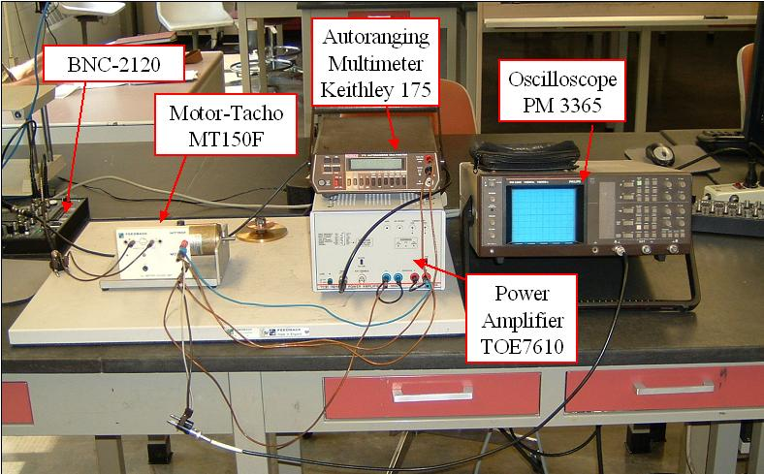
Figure 4. Basic Equipment Setup & Labeling of Equipment

Note: Figure 5 below shows the wiring diagram for the setup in Figure 4.

3.2. Basic setup (refer to circuit diagram Fig 5 given below)
1. In order avoid short-circuit; make sure that the power amplifier TOE7610 is turned off while wiring the system.

2. The input signal to the power amplifier TOE7610 will be provided from the LabVIEW program “motorstep.vi” via “DAC0” port of BNC-2120. The LabVIEW program motorstep.vi can be downloaded from the course website. Save it on the desktop.

3. Using a “T” connector and a BNC cable, connect the DAQ card labeled “ACH0” of BNC-2120, the DAQ card labeled “DAC0” of BNC-2120 and the “input” port of the amplifier TOE7610 together. Signal at ACH0, which is same as the input signal to the amplifier, will be displayed by the motorstep.vi program.

4. Insert jumpers between the output “large +” and the sensor “small +” ports of TOE7610. Similarly, insert jumpers between the output “large –” and the sensor “small –” ports of TOE7610. These “small+” and “small –“ signals provide feedback to the TOE7610 power amplifier to yield a stable output voltage.

5. Connect the output “large +” port of TOE7610 to the input red port of the DC motor-tacho unit MT150F. Similarly, connect the output “large –” port of TOE7610 to the input black port of the DC motor-tacho unit MT150F. This provides the second power input to the DC motor-tacho unit.

6. Connect the input red and black ports of the DC motor-tachometer unit MT150F to channel A of oscilloscope so that you can see MT150F input (i.e. TOE7610 output) on the oscilloscope.

Use the BNC cable and the pig-tail connector provided. The red cable should be connected to red port and black cable to black port. Turn on the oscilloscope and set the ground to the middle of the screen. Also, make sure that the measurement signal can be completely viewed on the oscilloscope and the mean voltage can be read. (Ask your TA if you need a refresher on setting up an oscilloscope.)

7. Using BNC cable, connect the output ports 1 and 2 of MT150F to the DAQ card labeled “ACH1” of BNC-2120 so that you can see DC motor-tacho unit MT150F output on the Labview software.

8. Make sure that the inertia disk in not mounted on the motor shaft.

Figure 5. Circuit Diagram of the DC motor setup

4. Experimental Procedures

Part A: Steady state response

Procedure: In this part, you will characterize the relation between the armature voltage (input) of the motor and the resulting angular speed (output). The tachometer attached on the MT150F unit will provide voltage signal, which is proportional to motor angular speed. By providing a sequence of constant voltages (from mean voltage between 0 and 5 V with step of ±0.5V) at the input of the power amplifier, you will record the resulting tachometer voltage.

** Remember to observe the effects on motor speed throughout the experiment.

1. Double click on the motorstep_8.2.vi icon on the desktop.

2. Make sure the Amplitude, the Offset, and the Period on the motorstep.vi program window are set to 0.0V, 0.0V and 5.0 sec, respectively. The motor should be stopped at this point.

3. Click the “Run” (arrow sign) button on the program window.

4. Turn on the TOE7610 power amplifier, the multimeter and the oscilloscope. Monitor the system’s response with the three (3) measurement devices.

5. Use the multimeter to measure the differential voltage at the input ports to the motor (Red and Black) as well as that at the output ports (1 and 2), which is read in LabVIEW. Record the two readings against the mean drive value in the LabVIEW program window. The readings of the Motor Tachometer (MT150F) input and output voltages should match with that on oscilloscope and motorstep.vi, respectively.

6. Click on the Stop button on the program window.

7. Increase the offset on the motorstep.vi by 0.5V and repeat steps 4 to 6 till the offset is 5V. You will notice that the motor starts to rotate after a certain voltage.

8. Using MS Excel or Matlab, plot the relationship between the motor output (tachometer voltage) and the motor input (i.e. amplifier output), the motor gain () can be found from this plot. Also, plot the offset value against the motor output (tachometer voltage), the system gain (K) can be found from this plot.

Questions to answer in the short form:
A.1. Is the relationship between armature voltage (input) and steady state motor speed (output) linear? If not, specify the range of the input voltage in which the relationship is linear.

A.2. In the linear range, what is the motor DC gain () from the input to the output? Is this gain the same as the gain when input is zero? What is the unit of measurement for the gain?

Part B: Transient response: Effect of operating point

Procedure: In this section, you will analyze the effect of step input and its mean operating point on the transient response of the DC motor. The step input (about a mean operating voltage) will be provided from the LabVIEW program “motorstep.vi”.

1. Set the following values on the motorstep.vi program window:
Period = 1sec
Offset = 0V
Amplitude = 0.5V

2. Click the “Run” (arrow sign) button on the program window.

3. Print out the LabVIEW window showing the plot of the command and motor response signals. From the plot, calculate the steady-state DC gain ( K ) of the system. (Refer to page 2 Eq.(3) and Figure(1) to check how to find DC gain and the Time Constant from the generated plot). From the plot, calculate the time constant for the rise and also for the fall. Calculate the average of these two time constants. Unless specified, the time constant () at the given operating point can be taken as this average value.

4. Measure the amplitude of the square wave on the oscilloscope and record it. Using this value and the LabVIEW plot, calculate the amplifier gain () and the motor DC gain (). The values of, and should be in agreement with equation (13).

5. Click on the Stop button on the program window.

6. Denote the calculated values from steps 1-5 of Average Time Constant (), Amplifier Gain (), Motor Gain () and Overall System Gain (). Now, increase the mean drive voltage on the motostep.vi to 4V and repeat steps 2 through 5. Denote the new calculated values of Average Time Constant (), Amplifier Gain (), Motor Gain () and Overall System Gain ().

Questions:

B.1. For the operating point (offset) of 0V, what are the values for the time constants for the rise and the fall? Are these two time constants same? Why is it so? Write down the average of the two values.

B.2. For the operating point (offset) of 4V, what are the values for the time constants for the rise and the fall? Are these two time constants same? Why is it so? Write down the average of the two values.

B.3. Write down the values of , , , , , , and . Are , , and equal to , , and , respectively? Is it as you expected? Explain your answer.

B.4. Which operating point (0V or 4V) do you think is the better for this idealized first-order linear system and why?

Part C: Transient response: Effect of varying rotor inertia J

Procedure: In this section you will experimentally validate the change in motor transient response with change of motor inertia.

1. Securely mount the inertia disk on the motor shaft.

2. Make sure the following values are on the motorstep.vi program window:
Period = 5.0 sec
Offset = 4V
Amplitude = 0.5V

3. Perform steps 2 through 5 of part B for motor with inertia disk. Denote the new calculated values of Average Time Constant, Amplifier Gain, Motor Gain and Overall System Gain as , , and , respectively.

Questions:

C.1. Write down the values of , , and . Are , , and equal to , , and , respectively? Is it as you expected? Explain your answer.

C.2. Knowing that the inertia disk weighs 438 grams, compute its moment of inertia. You will need to measure the radius of the disk.

C.3. Knowing that the time constant is directly proportional to the inertia of the rotor, as seen in Equation (12), use the values , and the inertia of the disk to compute the inertia of the motor shaft in the absence of the disk.

5. Conclusion

Summarize the lessons you have learned from this laboratory experience, in few sentences.
A.1. Is the relationship between armature voltage (input) and steady state motor speed (output) linear? If not, specify the range of the input voltage in which the relationship is linear.

[ YES / NO ] (Encircle the right answer)

[ Range: ]
(Attach plot)

A.2. In the linear range, what is the motor DC gain (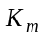) from the input to the output? Is this gain the same as the gain when input is zero? What is the unit of measurement for the gain?

[Motor DC Gain, : ]

[Related? YES / NO ] (Encircle the right answer)

[Unit for gain: ]

B.1. For the operating point (offset) of 0V, what are the values for the time constants for the rise and the fall? Are these two time constants same? Why is it so? Write down the average of the two values.

Time constant for rise | Time constant for fall | Average

B.2. For the operating point (offset) of 4V, what are the values for the time constants for the rise and the fall? Are these two time constants same? Why is it so? Write down the average of the two values.

Time constant for rise | Time constant for fall | Average

B.3. Write down the values of , 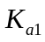,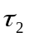,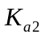 and calculate 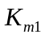, 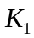, 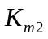and 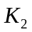.
Are , , and equal to , , and , respectively? Is it as you expected? Explain your answer.

B.4. Which operating point (0V or 4V) do you think is the better for this idealized first-order linear system and why?

C.1. Write down the values of 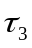, 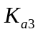, , and calculate 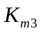and 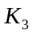. Are , , and equal to , , and , respectively? Is it as you expected? Explain your answer.

C.2. Knowing that the inertia disk weighs 438 grams, compute its moment of inertia. You will need to measure the radius of the disk. (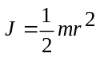)

[ J disk: ]
(Write proper units)

C.3. Knowing that the time constant is directly proportional to the inertia of the rotor, as seen in Equation (12), use the values , and the inertia of the disk to compute the inertia of the motor shaft in the absence of the disk.

[J shaft: ]
(Write proper units)

D: Summarize the lessons learned in this lab.

